SOA EXPERIMENT – 6

Library Management Microservice (CRUD)

STEP1 – create a spring boot project
-> in spring tool suite:
- file → new → spring starter project
- project name:
soa_library-service
- type: maven
- packaging: jar
- java: 17
- select:
  - spring web
  - spring data jpa
  - postgresql driver
  - validation
- click finish

STEP2 – project structure
SOA_library-service
│
├── src/main/java
│ └── com.example.demo
│ ├── SoaLibraryServiceApplication.java
│ ├── Book.java
│ ├── BookRepository.java
│ └── BookController.java
│

│ └── application.properties
│
├── src/test/java
│
├── Maven Dependencies
│
└── pom.xml

STEP3 – Configure PostgreSQL Database
-> create a database in pgadmin 4 – “librarydb”
-> then configure application.properties
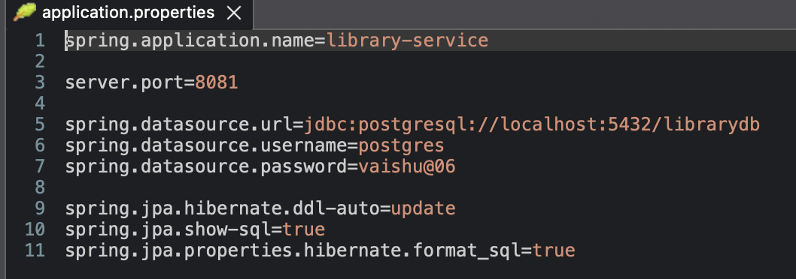

STEP4 – create a book entity
-> create a class book.java
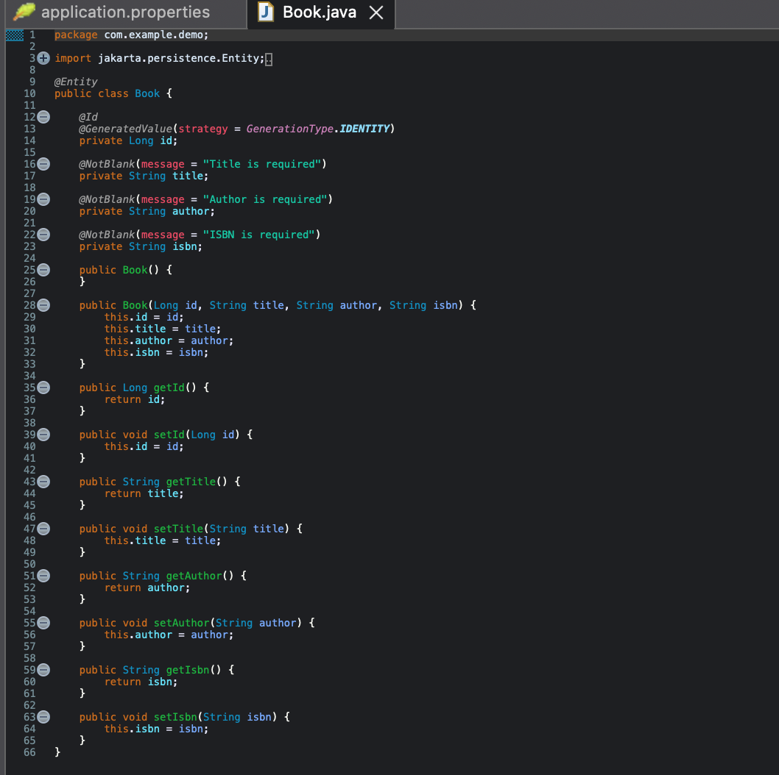

STEP5 – Create a Repository
-> class – “bookRepository.java”
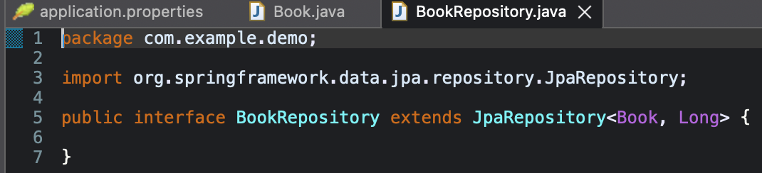

STEP6 – Create RestController
->create – “BookController.java”
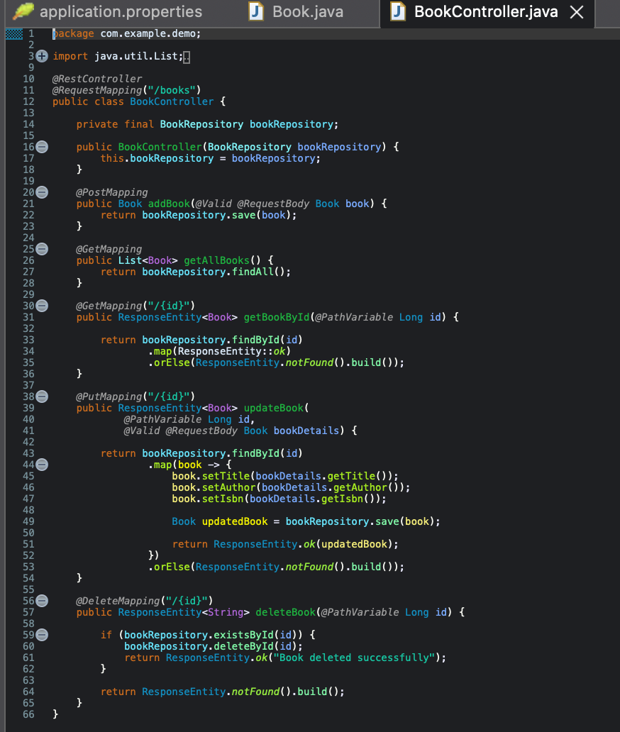

STEP7 – Run the application
-> Right click - SoaLibraryServiceApplication.java
→ Run As
→ Spring Boot App

STEP8 – Test Create Operation (POSTMAN)
-> Select – “post”
-> URL:- http://localhost:8081/books
-> Body > raw > json and send
{
"title": "The Alchemist",
"author": "Paulo Coelho",
"isbn": "9780061122415"
}
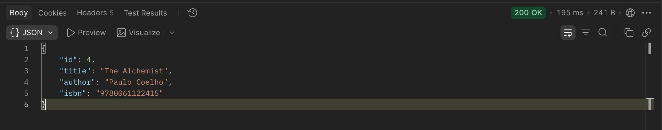

STEP9 – Test Read Operation
-> Select – “get”
->URL:- http://localhost:8081/books
->click – “none” and send
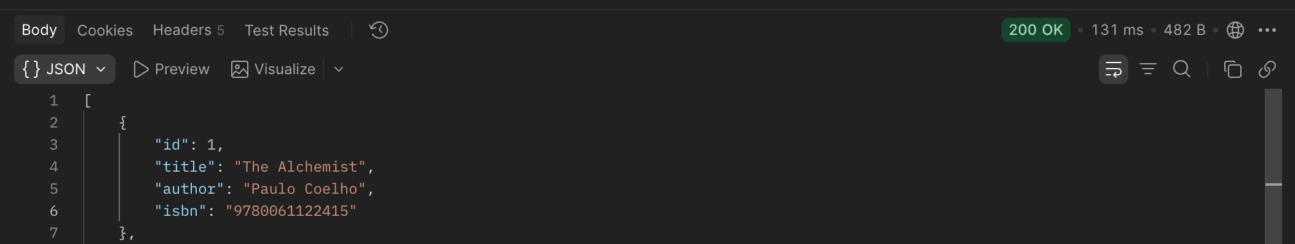

STEP10 – Test Reas By ID
-> Select – “get”
->URL:- http://localhost:8081/books/1
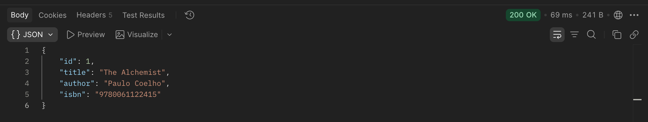

STEP11 – Test Update Operation
-> Select – “put”
->URL:- http://localhost:8081/books/1
-> Body > raw > json and send
{
"title": "The Alchemist Updated",
"author": "Paulo Coelho",
"isbn": "9780061122415"
}
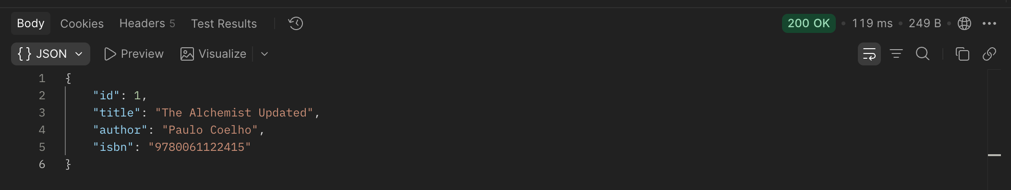

STEP12 – Test Delete Operation
-> Select – “delete”
-> URL:- http://localhost:8081/books/1
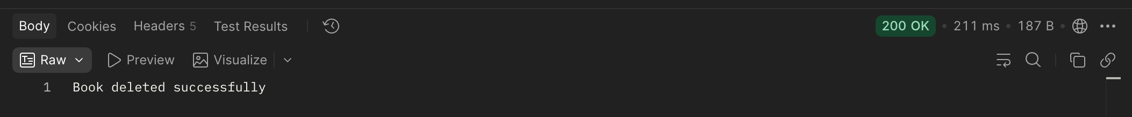

STEP13 – Validate Invalid Input
-> Select – “post”
-> URL:- http://localhost:8081/books
-> Body > raw > json and send
{
"title": "",
"author": "",
"isbn": ""
}
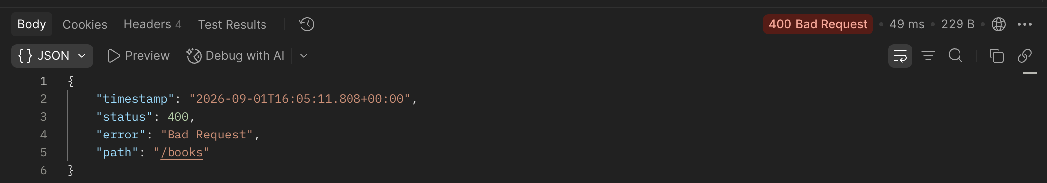

STEP14 – Verify Database
-> your table is currently – “book”
->run :- SELECT * FROM book;
